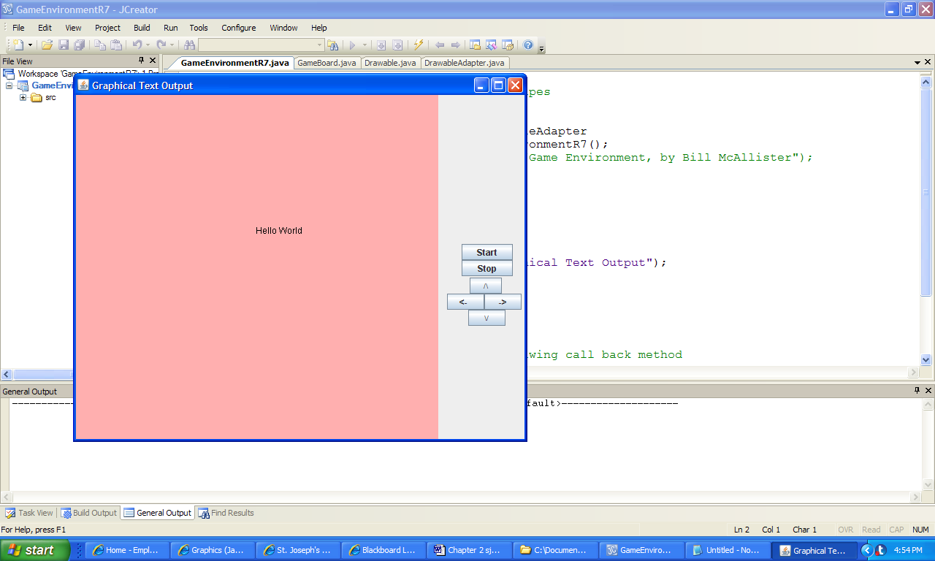

**Figure 2.11 The output produced by the application GraphicalTextOutput.**